Grouped products (variants)

Grouped products, or products with variants, are a convenient tool to sell a product that has various supplementary items or attribute sets. Various combinations of such a product can be sold as separate products, and the price may vary.

In nopCommerce, grouped products look like a single product details page displaying all the possible options. It is a convenient and SEO-friendly tool to sell complex products.

**TIP**

For example, a base product, such as a camera body, can be grouped with various sets of lenses. Another use case of a grouped product is selling a type of product with various attribute sets. For example, chocolate with various flavors. In this case, a customer can easily see the main product and all its options on the same page.

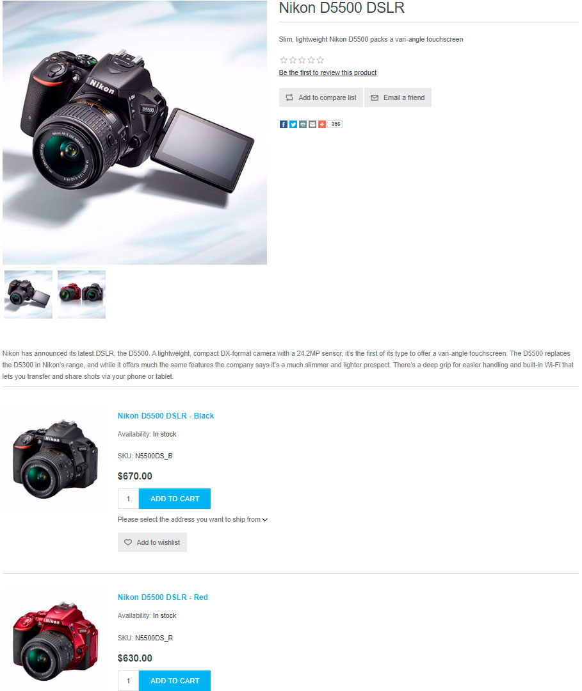

Adding a new grouped product

To create a grouped product, go to **Catalog → Products**. There are several steps to follow:

**TIP**

Learn how to fill in the product fields [here](https://docs.nopcommerce.com/en/running-your-store/catalog/products/add-products.html).

1. Create several products with a *simple* product type. These are the variants of the main product. Use the **Visible individually** checkbox to define whether you want them to be visible separately in catalog and search results or only shown on the product page of the main product.
2. Create a **Grouped (product with variants)** product and assign these simple products you created in the previous step in the **Associated products (variants)** panel:

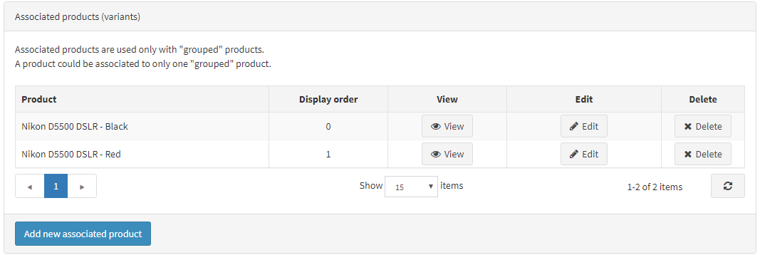

**NOTE**

* In the public store, a customer sees a separate **Add to cart** button for each associated product on the *grouped* product details page.
* A *simple* product can only be associated with one *grouped* product.
* *Grouped* products are **not orderable directly**. However, *simple* products are associated with them. For example, a customer cannot order the Creative Sound Card product directly. Instead, they must order an OEM or Retail version of the Creative Sound Card. In this case, the *grouped* product is the Creative Sound Card, and there are two associated *simple* products for this *grouped* product: OEM and Retail, each with potentially different prices.